# IoT Project:

## Home Automation System:

Homes of the 21st century will become more and more self-controlled and automated due to the comfort it provides, especially when employed in a private home. A home automation system is a means that allow users to control electric appliances of varying kind. Many existing, well-established home automation systems are based on wired communication. This does not pose a problem until the system is planned well in advance and installed during the physical construction of the building. But for already existing buildings the implementation cost goes very high.

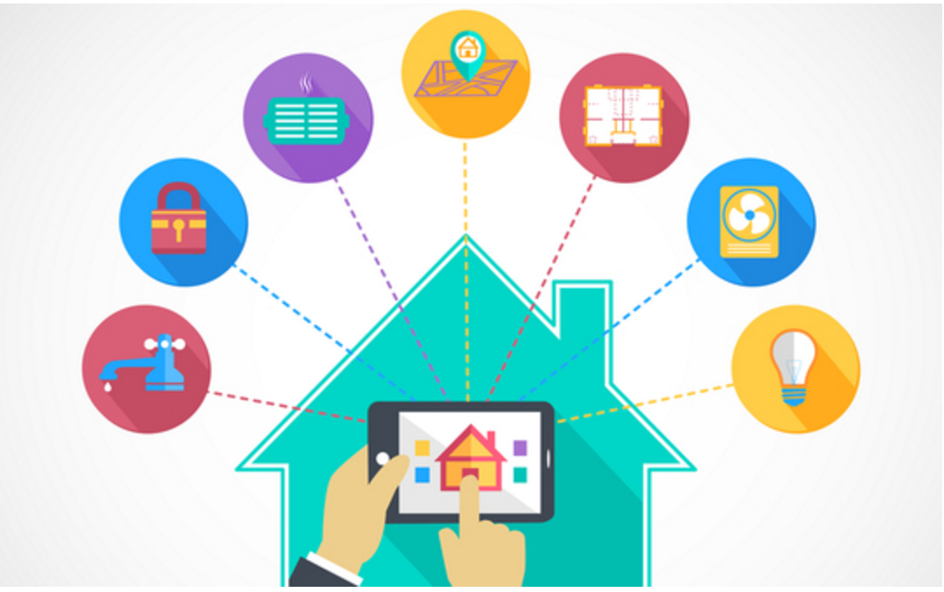

As everyday devices increasingly find their way online, we have seen a plethora of 'things' around the home becoming smarter - mainly owing to a new-found ability to connect to the internet - or a number of things you'd not usually find in the home making their way there owing to advances in technology making them cheaper and more accessible.

There are many applications available that provide this facility. We are proposing an application that can be built at a very low cost. We can build a simple raspberry pi home automation system that will allow you to control appliances in your home from anywhere in the world. And it will also allow you to view data from the PIR motion sensor via the Internet to detect intruders. This project will be using platforms like the Raspberry Pi, IBM’s IoTF (Internet of Things Foundation) and Blue mix packages.

**Hardware:**

1. Raspberry Pi 2 / B+.
2. USB wifi dongle.
3. USB keyboard and mouse.
4. HDMI monitor and cable.
5. Micro USB power adapter (smartphone charger).
6. PIR motion sensor.
7. Male-female and male-male jumpers.
8. Breadboard.
9. BC547 transistor.
10. 5V SPDT relay and 1n4001 diode.
11. LED and 220Ohm resistor.

**Software:**

Raspbian OS

The Raspberry Pi home automation system uses client and server side python scripts. These can communicate with each other through IBM’s IoTF platform.

This whole Internet of Things project can be divided into two parts:

**1. Sending commands to the Raspberry Pi**

The server side script running on our laptop or on a web server takes input commands from the user and correspondingly sends it to the client (Raspberry Pi). Here, we will be using commands to turn a light ON/OFF. When we pass the command to turn ON a light through the server side script, the information is relayed to the Raspberry Pi and it’s GPIO pin turns ON a relay. The system also sends status updates to the server on whether the light is ON/OFF.

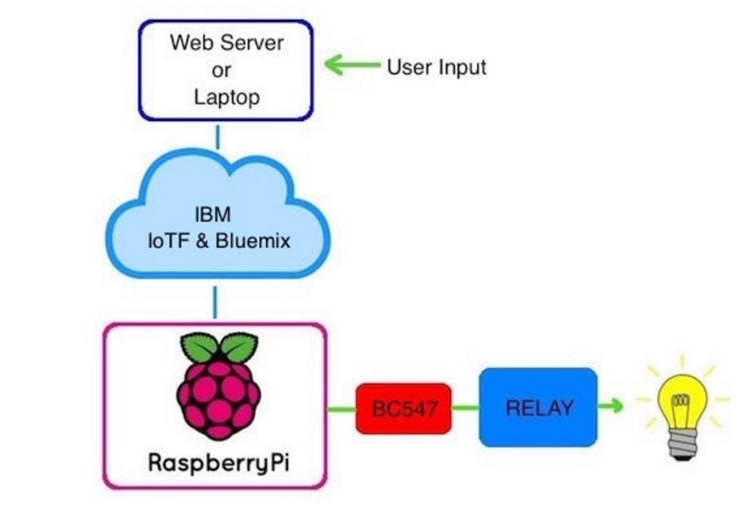

**2. Receiving data from the Raspberry Pi**  
In case of sending data from the PIR motion sensor connected to the Raspberry Pi, we run a script which reads the sensor through a GPIO pin and broadcasts the data through the IoTF platform. This can then be viewed through the IoTF console or through a custom web application designed using the platform.

